assignment:-
1...What is a Program?
ans : A program is instructions for a computer to execute specific tasks.
LAB EXERCISE: Write a simple "Hello World" program in two different programming languages of your choice. Compare the structure and syntax.
ANS.. PHYTON
print("Hello, World!")
#include <stdio.h>
C LANGU
int main() {
printf("Hello, World!\n");
return 0;
}
Comparison of Structure and Syntax
Feature Python C
Simplicity Very simple and concise (1 line) More verbose, requires boilerplate
Compilation Interpreted (no need to compile) Compiled (must be compiled first)
Function Definition Not required for basic print Must define a main() function
Libraries No import needed for printing Needs #include <stdio.h>
Semicolons Not required Required at end of statements
Newline Handled automatically by print() Must explicitly add \n

THEORY EXERCISE: Explain in your own words what a program is and how it functions.
ANS A program is a set of instructions written in a language that a computer can understand and execute. Think of it like a recipe that tells the computer what steps to follow to perform a specific task—whether that’s adding numbers, displaying a website, or running a game.

How it functions:
1...Written by a programmer – A person writes the program using a programming language like Python, Java, or C++.

2....Translated into machine code – The instructions are either compiled or interpreted into machine language (binary code) that the computer’s hardware can understand.

3......Executed by the computer – The computer follows the instructions step by step. It processes data, performs calculations, makes decisions (like “if this happens, do that”), and interacts with hardware (like displaying something on the screen).

What is Programming?
Programming is the process of creating a set of instructions that a computer can follow to perform a specific task or solve a problem. These instructions are written using a programming language, such as Python, Java, C++, or JavaScript.

What are the key steps involved in the programming process?
The key steps in the programming process typically include: defining the problem, designing a solution (including algorithm development), coding the solution, testing and debugging, and finally, documentation and maintenance.
1. Problem Definition:
This initial step involves clearly understanding the problem that needs to be solved. It requires defining the input, the desired output, and the boundaries of the problem.
2. Problem Analysis:
After defining the problem, the next step is to analyze it. This includes identifying the necessary variables, functions, and other resources needed to solve the problem, as well as determining the bounds of the solution.
3. Algorithm Development:
This step involves creating a step-by-step solution to the problem. This can be done using techniques like flowcharts or pseudocode, which visually or textually represent the logic of the program.
4. Coding:
Once the algorithm is developed, it's translated into a programming language. This involves writing the actual code, ensuring it adheres to the syntax and rules of the chosen language.
5. Testing and Debugging:
After coding, the program needs to be tested to ensure it works correctly and produces the desired output. Debugging is the process of finding and fixing errors or bugs in the code.
6. Documentation:
Good documentation is crucial for making the program understandable and usable. This includes writing user instructions, explaining the program's logic, and providing information about the input and output.
7. Maintenance:
Even after the program is complete, it will likely need maintenance. This may involve fixing bugs, adding new features, or adapting the program to new requirements.
Types of Programming Languages..
ANS:
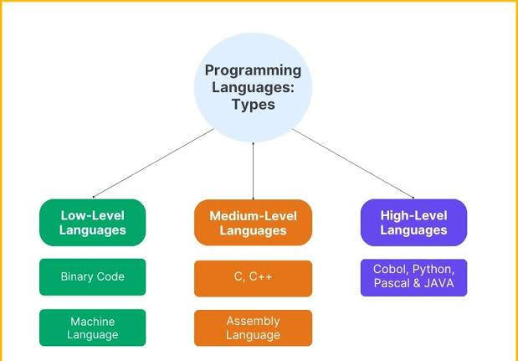

THEORY EXERCISE: What are the main differences between high-level and low-level
programminglanguages?

High-level languages prioritize ease of use and abstraction from hardware, while low-level languages offer direct control over hardware with minimal abstraction.
High-Level Programming Languages
Definition: High-level languages (HLL) are designed to be easy for humans to read and write. They use English-like syntax and abstract away the complexities of the computer's hardware.
Characteristics:
Abstraction: They provide a high level of abstraction from machine code, allowing developers to focus on programming logic rather than hardware specifics.
Ease of Use: High-level languages are generally easier to learn and use, making them suitable for beginners and rapid application development.
Portability: Code written in high-level languages can often run on different types of hardware with minimal changes, thanks to compilers and interpreters that translate the code into machine language.
Examples: Common high-level languages include Python, Java, C++, and JavaScript.
3 Sources
Low-Level Programming Languages
Definition: Low-level languages are closer to machine code and provide little abstraction from a computer's hardware. They are often used for system programming and performance-critical applications.
Characteristics:
Direct Hardware Access: Low-level languages allow programmers to write instructions that directly manipulate hardware, providing maximum control and efficiency.
Complexity: They are more difficult to read and write, requiring a deeper understanding of computer architecture and hardware operations.
Non-portability: Code written in low-level languages is often specific to a particular type of hardware, making it less portable than high-level code.
Examples: Common low-level languages include Assembly language and machine code.

World Wide Web & How Internet Works?
ANS
The World Wide Web is a system of interconnected documents and multimedia resources, accessed through the internet. Developed in 1989 by Tim Berners-Lee, the Web introduced a simple way to navigate information using hyperlinks. This innovation transformed computers from isolated tools into gateways for a vast network of knowledge and communication.
INTERNET WORKS:
Basic Concept of the Internet
The internet can be thought of as a network of networks. It connects millions of private, public, academic, business, and government networks, allowing them to communicate with each other. This interconnectedness enables users to access information, send emails, stream videos, and engage in various online activities seamlessly.
LAB EXERCISE: Research and create a diagram of how data is transmitted from a client to a server over the internet.
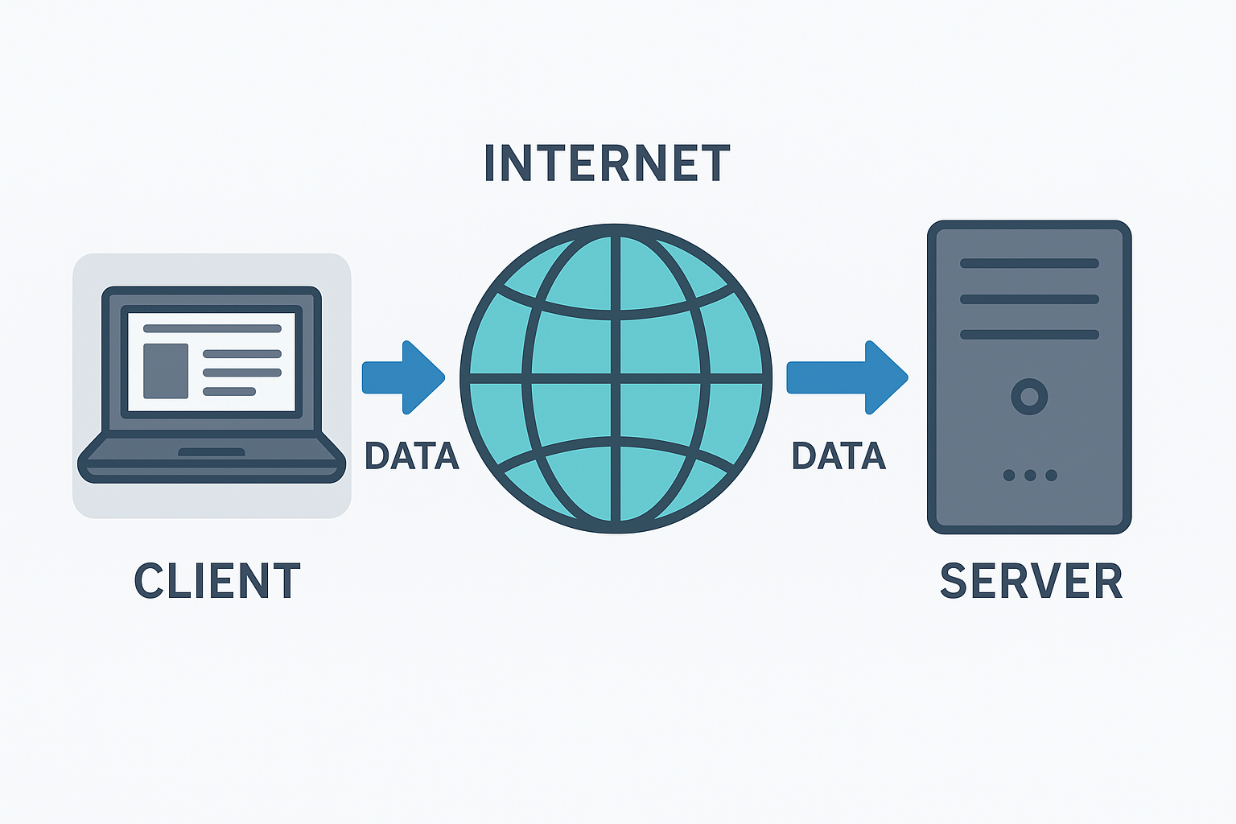
THEORY EXERCISE: Describe the roles of the client and server in web communication.
Network Layers on Client and Server
ANS:
1. Roles in Web Communication

Client
Initiator: Sends requests for resources (e.g., web pages, images, data).
Interface: Runs software like a web browser or mobile app to display results to the user.
Request Formatting: Uses protocols like HTTP/HTTPS to structure the request.
Example: Your browser asking www.example.com for index.html.
Server
Responder: Waits for incoming requests and responds with the requested resources or error messages.
Processor: May run back-end code (PHP, Node.js, Python, etc.) to generate responses dynamically.
Resource Provider: Sends HTML, CSS, JavaScript, images, or JSON back to the client.
Example: Apache/Nginx returning index.html with associated assets.

2. Network Layers (Client vs. Server)
Using the OSI model (conceptual) as the reference:
Layer (OSI) Client Role Server Role
7 – Application Browser formats HTTP/HTTPS request Web server application formats HTTP/HTTPS response
6 – Presentation Encrypts request (TLS/SSL) Decrypts request (TLS/SSL)
5 – Session Manages session state (cookies, tokens) Tracks session state for client
4 – Transport TCP segments request data TCP segments response data
3 – Network Adds IP source/destination addresses Adds IP source/destination addresses
2 – Data Link Frames data for local network (Ethernet/Wi-Fi) Frames data for local network
1 – Physical Sends electrical/optical/radio signals Sends electrical/optical/radio signals
Flow Summary
Client:
User clicks a link → Browser sends an HTTP GET request via TCP/IP.
Server:
Receives request → Processes → Sends back HTTP response.
Client:
Receives data → Browser renders the page.
THEORY EXERCISE: Describe the roles of the client and server in web communication.
Network Layers on Client and Server
ANS:-
1. Roles of the Client and Server in Web Communication
Side Role Examples
Client Initiates requests to get resources or services from a server. Usually a web browser, mobile app, or other software. A browser asking for index.html from a website.
Server Listens for incoming client requests, processes them, and sends back responses. Usually a web server program running on a machine. Apache, Nginx, or Node.js sending back HTML, CSS, JS, or data from a database.
Typical Flow (HTTP Example)

Client:

Enters a URL → browser sends an HTTP GET request.

Server:
Receives request → fetches resource → sends HTTP response with the content.

Client:
2. Network Layers on Client and Server

When the client and server talk over the internet, the communication travels through network layers (based on the TCP/IP model).
Both sides use the same stack, but for opposite purposes — one side sends, the other receives, and vice versa.

TCP/IP Layers
Layer Client Role Server Role
Application Layer Generates the request (e.g., HTTP GET) from the browser or app. Processes the request and generates a response (e.g., HTTP 200 + HTML).
Transport Layer (TCP) Breaks request into segments, adds port numbers (client ephemeral port → server port 80/443). Reassembles segments into the original message; sends response segments back.
Internet Layer (IP) Adds source/destination IP addresses (client’s IP → server’s IP). Receives IP packets, strips IP headers, sends to transport layer.
Network Access Layer Converts packets to frames, adds MAC addresses, sends bits over physical medium (Wi-Fi, Ethernet). Receives bits, reconstructs frames, extracts packets, sends to IP layer.

THEORY EXERCISE: Explain the function of the TCP/IP model and its layers.
Layers in the TCP/IP Model
The TCP/IP model is a foundational framework for modern networking, widely used for internet communication. It organizes networking tasks into four layers, each with specific responsibilities, ensuring efficient data transmission and reception.

1. Application Layer

This is the topmost layer, closest to the user. It provides services like web browsing, email, and file transfers. Protocols such as HTTP, FTP, SMTP, and DNS operate here. It handles data formatting, encryption, and session management to ensure seamless communication between applications.

2. Transport Layer

The transport layer ensures reliable data delivery between devices. It uses protocols like TCP (for reliable, ordered delivery) and UDP (for faster, less reliable communication). This layer manages error detection, retransmission of lost data, and maintaining the correct sequence of packets.

3. Internet Layer

This layer is responsible for routing and forwarding data packets across networks. It uses the IP protocol to assign unique addresses to devices and determine the best path for data transmission. Tasks like packet fragmentation and reassembly are also handled here.

4. Network Access Layer

The lowest layer deals with the physical transmission of data over hardware like cables, switches, or wireless signals. It uses MAC addresses for device identification and formats data into frames for transmission. Error detection at the hardware level is also managed here.

Why TCP/IP is Widely Used

The TCP/IP model is simpler than the OSI model, with only four layers compared to seven. It is practical, protocol-driven, and widely adopted for real-world networking. Its flexibility, scalability, and interoperability make it the backbone of the internet.

Advantages

Interoperability: Enables communication between diverse systems.

Scalability: Suitable for both small and large networks.

Reliability: Includes error-checking and retransmission mechanisms.

Flexibility: Adapts to various data types and communication methods.

Limitations

Security Concerns: Initially designed without security in mind.

Overhead: TCP introduces significant overhead for reliability.

Address Space: IPv4's limited address space led to the adoption of IPv6.

THEORY EXERCISE: Explain Client Server Communication

ANS:1. The Core Idea

At its heart, client–server communication is about two machines talking to each other over a network.

Client → The "requester" of a service or data (like your web browser, mobile app, or email program).

Server → The "provider" that stores, processes, and delivers the requested data or service.

Think of it like a restaurant:

You (Client) read the menu and place an order.

The kitchen (Server) prepares the meal.

The waiter (Network) carries the request to the kitchen and brings the food back.

2. How It Works (Step-by-Step)

Connection – The client finds the server’s address (like a restaurant’s location) and connects, often using an IP address + port number.

Request – The client sends a request message (e.g., "Give me the homepage") using a protocol like HTTP.

Processing – The server receives the request, processes it (runs code, queries a database, etc.).

Response – The server sends back the response message (e.g., HTML, JSON, image data).

Disconnection – In many cases (like HTTP), the connection closes after the response. In others (like WebSockets), it stays open for continuous communication.
QUE Types of Internet Connections?
ANS 1. Dial-Up Connection
A dial-up connection is established between your computer and the ISP server using a modem. A dial-up Connection is a cheap and traditional connection that is not preferred these days as this type of connection is very slow.
To access the internet connection in the dial-up connection we need to dial a phone number on the computer and that's why it requires a telephone connection. It requires a modem to set up a dial-up connection, which works as interference between your computer and the telephone line. In this connection, we can use either an internet connection or a telephone at a time.
2. Broadband Connection
Broadband refers to high-speed internet access that is faster than traditional dial-up access. It is provided through either cable or telephone composition. It does not require any telephone connection that's why here we can use telephone and internet connection simultaneously. In this connection, more than one person can access the internet connection simultaneously.
3. DSL (Digital Subscriber Line)
DSL stands for Digital Subscriber Line. It provides an internet connection through the telephone line(network). DSL is a form of broadband communication that is always on, there is no need to dial a phone number to connect. DSL connection uses a router to transport data and the speed of this connection range between 128k to 8Mbps depending on the service offered. A DSL connection can translate data at 5 million bytes per second, or 5mbps.
4. Cable
It is a form of broadband access cable modem that can provide extremely fast access to the internet. The speed of this connection varies which can be different for uploading data transmission or downloading.
It uses a cable modem to provide an internet connection and operates over cable TV lines. The speed of cable connection ranges from 512k to 20Mbps.h
LAB EXERCISE: Research different types of internet connections (e.g., broadband, fiber,satellite)and list their pros and cons.

THEORY EXERCISE: How does broadband differ from fiber-optic internet?
Broadband and fiber-optic internet are related, but not the same thing — one is a category of internet connections, and the other is a specific technology within that category.
Here’s the breakdown:
1. Broadband — the umbrella term
Definition: Any high-speed internet connection that’s always on (doesn’t require dial-up).
Technologies it can include:
Fiber-optic (the fastest and most modern form)
Cable internet (via coaxial TV cables)
DSL (via phone lines)
Satellite internet
Fixed wireless
Speed range: Can vary greatly — from around 25 Mbps (the FCC’s minimum definition) to 1+ Gbps, depending on the technology.
Main idea: “Broadband” is a broad category, not a specific technology.
2. Fiber-optic internet — a specific broadband technology

Definition: Uses thin strands of glass or plastic fibers to transmit data as light signals.

Speed & reliability:

Typically offers hundreds of Mbps to multiple Gbps (both download and upload).

Less prone to slowdowns from electrical interference or distance.

Latency: Extremely low, making it excellent for gaming, video conferencing, and real-time applications.

Availability: Limited in some regions — rolling out gradually.

Examples: Verizon Fios, Google Fiber, AT&T Fiber.

Key Differences at a Glance
Feature Broadband (General) Fiber-Optic Broadband
Definition Any high-speed, always-on internet A type of broadband using light over fiber cables
Speed 25 Mbps – 1+ Gbps (varies) 300 Mbps – 5+ Gbps typical
Latency Varies by tech Very low
Reliability Depends on tech & location Very high
Availability Widely available in many forms Growing, but not everywhere

LAB EXERCISE: Simulate HTTP and FTP requests using command line tools (e.g., curl).

THEORY EXERCISE: What are the differences between HTTP and HTTPS protocols?

ANS HTTP (Hypertext Transfer Protocol) and HTTPS (Hypertext Transfer Protocol Secure) are both used to transfer data between a web browser and a web server, but they differ in security, performance, and trustworthiness.

Here’s a clear breakdown:

Feature HTTP HTTPS
Security No encryption — data is sent in plain text, making it vulnerable to eavesdropping, tampering, and man-in-the-middle attacks. Encrypted using SSL/TLS — protects against eavesdropping, tampering, and impersonation.
Port Uses port 80 by default. Uses port 443 by default.
Data Integrity No protection from data being altered in transit. Ensures data integrity — detects and prevents modification of transmitted data.
Authentication No guarantee that the website is legitimate phishing is easier.
SSL/TLS certificates verify the identity of the website.
Speed Slightly faster because it doesn’t encrypt data, but vulnerable. Slightly slower due to encryption overhead (though with modern hardware and HTTP/2/3, the difference is negligible).
SEO & Browser Warnings No ranking boost; modern browsers may label it as “Not Secure.” Search engines like Google give ranking boosts; browsers display a padlock icon for trust.
Use Cases Suitable only for non-sensitive public content. Required for sensitive transactions (e.g., banking, login forms, e-commerce).
In short:
HTTP = Fast but insecure.
HTTPS = Secure, trusted, and the modern standard.

THEORY EXERCISE: What is the role of encryption in securing applications?

Encryption’s role in securing applications is to protect sensitive data from unauthorized access—both when it’s stored (“at rest”) and when it’s moving over networks (“in transit”).

Here’s how it works and why it matters:

1. Protecting Data Confidentiality

Encryption transforms readable data (plaintext) into an unreadable form (ciphertext) using an encryption algorithm and a key.

Only someone with the correct decryption key can convert it back to its original form.

This ensures that even if an attacker gains access to stored files or network traffic, the information remains useless without the key.

2. Securing Data in Transit

Applications often send data between users, servers, and third-party services.

Transport Layer Security (TLS) encrypts this communication so eavesdroppers can’t intercept or tamper with it.

3. Securing Data at Rest

Databases, configuration files, and backups can be encrypted.

Even if a storage medium is stolen (e.g., a lost laptop or breached server), encrypted data remains protected.

4. Supporting Integrity and Authentication

While encryption mainly ensures confidentiality, certain encryption schemes (like AES-GCM or public-key cryptography with digital signatures) also verify that:

Data hasn’t been altered (integrity).

The sender is who they claim to be (authentication).

5. Meeting Compliance Requirements

Many regulations (e.g., GDPR, HIPAA, PCI DSS) require strong encryption to protect personal and financial data.

LAB EXERCISE: Identify and classify 5 applications you use daily as either system software
orapplication software.
Here’s an example classification of 5 applications many people use daily:

Application Purpose Type Reason
Google Chrome Web browsing Application software Lets the user browse websites, stream videos, and access online tools.
Microsoft Word Document creation Application software Used for writing, formatting, and editing text documents.
Windows 11 Operating system System software Manages hardware, runs applications, and provides the user interface.
Antivirus software (e.g., Windows Defender) Protects system from malware System software Works in the background to secure the system and monitor threats.
File Explorer File management System software Comes with the OS to organize, move, and manage files and folders.

THEORY EXERCISE: What is the difference between system software and application software?
Software Architecture

In software architecture, system software and application software are two broad categories, and they differ mainly in purpose, scope, and level of interaction with hardware.

1. System Software
Definition:
System software acts as the foundation for running and managing computer hardware, providing essential services for application software.
Key Points:
Purpose: Manages hardware resources and provides a platform for application software to run.

Examples:
Operating Systems (Windows, Linux, macOS)
Device Drivers
Firmware
Utility Programs (disk management, antivirus, backup tools)
Characteristics:
Works close to the hardware.
Runs in the background.
Not directly used for end-user tasks.
2. Application Software

Definition:
Application software is designed for specific user tasks or problem-solving on top of the system software.

Key Points:
Examples:

Microsoft Word, Excel

Web Browsers (Chrome, Firefox)

Games

Mobile Apps (WhatsApp, Instagram)

Characteristics:

Runs on top of system software.

Directly interacts with the user.
Task-oriented.
Quick Comparison Table
Feature System Software Application Software
Primary Role Manages hardware & system operations Performs specific user tasks
User Interaction Minimal (mostly indirect) Direct and frequent
Dependency Runs without application software Requires system software to run
Examples OS, drivers, firmware Word processors, browsers, games
Level Low-level (close to hardware)

LAB EXERCISE: Design a basic three-tiersoftware architecture diagram for a web application.

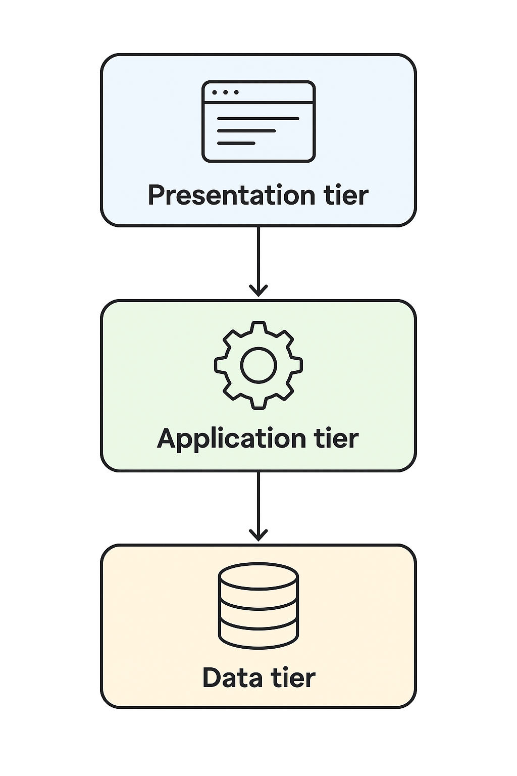
THEORY EXERCISE: Why are layers important in software architecture?
Separation of Concerns
Each layer has a specific responsibility (e.g., UI, business logic, data access).
Changes in one layer (like updating the database schema) don’t force massive rewrites in others.
Modularity
Code is organized into self-contained sections, making it easier to understand and test.

Teams can work in parallel on different layers without stepping on each other’s toes.
Maintainability
Bugs are easier to locate because responsibilities are clearly defined.
Future upgrades (e.g., swapping a database) are less painful since dependencies are controlled.
Reusability
Common functions in a layer (like authentication logic in the business layer) can be reused across multiple parts of the application.
Flexibility & Scalability
Layers can be replaced or scaled independently (e.g., scaling only the data layer for heavy reporting).

Testability
With clear boundaries, each layer can be unit tested in isolation using mocks or stubs.
Example:
Think of a layered architecture as a cake:
Presentation layer = the frosting (user-facing).
Business logic layer = the sponge (core rules & processes).
Data access layer = the base plate (handles persistence).
LAB EXERCISE: Create a student account on Github and collaborate on a small project with
aclassmate.
1. Create a GitHub Student Account

Sign up on GitHub

Go to https://github.com and click Sign up.

Use your school email if possible.

Apply for the GitHub Student Developer Pack

Visit https://education.github.com/pack.

Click Get Student Benefits.

Verify with your school email or upload proof of student status (e.g., student ID card).

2. Set Up the Collaboration Project

One person creates a repository

After logging in, click the + in the top right → New repository.

Give it a name (e.g., class-collab-project) and choose Public or Private.

Initialize it with a README.md.

Add your classmate as a collaborator

Go to Settings → Collaborators & teams.

Add their GitHub username.

They’ll get an email invitation to accept.

3. Clone the Repository Locally

Install Git if you don’t have it: https://git-scm.com/downloads

Open your terminal (or Git Bash) and run:

git clone https://github.com/<username>/<repo-name>.git

4. Work on the Project Together

Example: create a small project like a simple HTML page, Python script, or Java program.

Each collaborator creates a branch for their work:

git checkout -b feature-add-page

Add changes and commit:

git add .
git commit -m "Added new page"

Push to GitHub:

git push origin feature-add-page

5. Merge Changes

On GitHub, open a Pull Request for your branch.

Review each other’s code.

Merge into main when approved.

6. Example Project Idea

A simple "Student Contact Directory":

HTML/CSS page showing your names, emails, and a fun fact.

One person designs layout, the other adds content.
THEORY EXERCISE: What are the benefits of using Github forstudents?
Using GitHub as a student offers a lot more than just storing code — it’s like having a portfolio, collaboration tool, and learning platform all in one. Here are the main benefits:

1. Version Control Skills

You learn Git, one of the most in-demand developer skills.

Every change you make is tracked, so you can revert to earlier versions and understand your code’s history.

2. Collaboration Practice

You can work with classmates on projects in real time without overwriting each other’s work.

Pull requests, branches, and issue tracking teach you professional workflows used in tech companies.

3. Portfolio Building

Your GitHub profile becomes a public portfolio that recruiters can see.

Hosting class projects, hackathon entries, or personal code here showcases your skills.

4. Access to Learning Resources

You can explore open-source projects to learn from real-world code.

Following other developers and contributing to projects gives hands-on experience.

5. Free Tools for Students (via the GitHub Student Developer Pack)

Free access to premium GitHub features and partner tools like

Free domain names

Cloud credits (AWS, Azure, DigitalOcean)

Design tools (Canva Pro, Figma)

Development services (JetBrains IDEs, MongoDB Atlas)

6. Project Management Skills

Use GitHub Issues, Projects, and Wikis to plan and document work.

Learn agile-like workflows before entering the job market.

7. Hosting and Deployment
LAB EXERCISE: Create a list of software you use regularly and classify them into the
followingcategories: system, application, and utility software.

1. System Software
(Controls and manages computer hardware and basic operations)

Microsoft Windows 11 (Operating System)

macOS Ventura (Operating System)

Linux Ubuntu (Operating System)

Android OS (Mobile Operating System)

Apple iOS (Mobile Operating System)

2. Application Software
(Programs for performing specific user tasks)

Microsoft Word (Word Processing)

Microsoft Excel (Spreadsheets)

Google Chrome (Web Browser)

Zoom (Video Conferencing)

Adobe Photoshop (Image Editing)

Spotify (Music Streaming)

Microsoft PowerPoint (Presentation Software)

3. Utility Software
(Helps maintain, protect, and optimize the computer)

WinRAR / 7-Zip (File Compression)

CCleaner (System Cleanup)

Norton / Avast Antivirus (Security)

Disk Cleanup (Windows Built-in)

Backup and Restore (System Backup Tool)

Malwarebytes (Malware Removal)

THEORY EXERCISE: What are the differences between open-source and proprietary software?
GIT and GITHUB Training
1. Differences Between Open-Source and Proprietary Software
Feature Open-Source Software Proprietary Software
Source Code Access Publicly available — anyone can view, modify, and redistribute it. Closed — only the owner/company can access and modify.
Licensing Free or under permissive licenses (e.g., MIT, GPL, Apache). Commercial licenses, usage restricted by terms.
Cost Often free (though some have paid support/services). Usually paid; one-time or subscription-based.
Development Model Community-driven — developers from around the world contribute. Company-driven — development controlled by a single organization.
Customization Highly customizable to suit needs. Limited customization; controlled by the vendor.
Support Community forums, documentation, open discussions. Official customer support, SLAs, and help desks.
Security Transparent — security flaws can be found and fixed by anyone. Security depends on vendor; vulnerabilities might remain hidden.
Examples Linux, LibreOffice, GIMP, Firefox. Microsoft Windows, Adobe Photoshop, macOS.

2. Git & GitHub Training Overview

Git and GitHub often get confused, but they are different things:

Tool What it is Purpose
Git A distributed version control system. Tracks changes to files (especially code) and helps multiple people work on a project without overwriting each other’s work.
GitHub An online hosting platform for Git repositories. Allows storing code in the cloud, collaborating, and using tools like pull requests, issues, and actions.
Basic Git Commands for Beginners
Command Description
git init Initialize a new Git repository.
git clone <url> Copy an existing repository from a server (like GitHub).
git status Check the current state of the repository.
git add <file> Stage changes to be committed.
git commit -m "message" Save staged changes to the repository history.
git push Upload commits to a remote repository.
git pull Download and merge updates from a remote repository.
git branch List, create, or delete branches.
git checkout <branch> Switch to a different branch.
git merge <branch> Merge another branch into the current one.
GitHub Workflow Example

Create a Repository on GitHub.
Clone it to your computer (git clone).
Make changes locally.
Stage (git add) and commit (git commit) your changes.
Push changes to GitHub (git push).

LAB EXERCISE: Write a report on the various types of application software and how they
improveproductivity.
Report on Various Types of Application Software and Their Role in Improving Productivity
1. Introduction

Application software refers to computer programs designed to perform specific tasks for users. Unlike system software, which manages computer hardware, application software enables individuals and organizations to accomplish day-to-day tasks efficiently. These applications have become essential tools for improving productivity across industries, education, communication, and personal use.

2. Types of Application Software
2.1 Word Processing SoftwareExamples: Microsoft Word, Google Docs, LibreOffice Writer
Purpose: Used for creating, editing, formatting, and printing text-based documents.
Productivity Impact:Speeds up document creation and editing.
Features like spell check, grammar correction, and templates save time.
Cloud-based word processors allow real-time collaboration from different locations.
2.2 Spreadsheet Software
Examples: Microsoft Excel, Google Sheets, Apple NumbersPurpose:
Used for data entry, calculations, analysis, and visualization.

Productivity Impact:
Automates complex calculations with formulas and functions.
Graphs and charts help in quick decision-making.
Data analysis tools like pivot tables streamline reporting.

2.3 Presentation SoftwareExamples:
Microsoft PowerPoint, Google Slides, Prezi
Purpose: Creates visual aids for meetings, lectures, and pitches.
Productivity Impact:
Enhances communication through visuals and animations.
Pre-designed templates save design time.
Allows quick updates and sharing for collaborative presentations.
2.4 Database Management Software (DBMS)
Examples: Microsoft Access, MySQL, Oracle Database
Purpose: Stores, organizes, and retrieves large amounts of data efficiently.
Productivity Impact:
Eliminates manual data handling.
Ensures quick access to accurate information.
Improves data security and reduces duplication.

2.5 Communication Software
Examples: Microsoft Teams, Slack, Zoom, Gmail
Purpose: Facilitates information exchange between individuals or groups.
Productivity Impact:
Enables instant messaging, video calls, and file sharing.
Reduces delays in decision-making.
Supports remote work and global collaboration.

2.6 Graphics and Multimedia Software
Examples: Adobe Photoshop, Canva, CorelDRAW, Final Cut Pro
Purpose: Used for creating and editing images, videos, and animations.
Productivity Impact:
Enhances marketing and branding efforts.

Streamlines content creation for advertising and education.
Provides ready-made design templates to save time.
2.7 Project Management Software
Examples: Trello, Asana, Microsoft Project, Jira
Purpose: Helps plan, execute, and track projects.
Productivity Impact:
Organizes tasks and deadlines.
Improves teamwork with shared project boards.
Tracks progress and resource usage in real time.

2.8 Enterprise Resource Planning (ERP) Software
Examples: SAP, Oracle NetSuite, Odoo
Purpose: Integrates various business processes like accounting, HR, sales, and inventory.
Productivity Impact:
Centralizes data for better decision-making.
Reduces manual errors and duplication.
Automates routine business operations.

3. How Application Software Improves Productivity
Enhanced Collaboration: Real-time document editing, video conferencing, and shared platforms connect teams instantly.

Faster Decision-Making: Analytical tools and dashboards provide quick insights from large data sets.

Resource Optimization: Efficient planning and tracking tools minimize wastage of time and resources.

Mobility: Cloud-based applications allow access from anywhere, enabling remote work flexibility.

4. Conclusion
Application software plays a vital role in boosting productivity by simplifying processes, enabling collaboration, and providing powerful tools for analysis and communication. In both personal and professional settings, the right application software can significantly enhance efficiency, accuracy, and overall output.

THEORY EXERCISE: What is the role of application software in businesses?
Software Development Process
Application software plays a crucial role in businesses by enabling organizations to perform specific tasks efficiently, automate processes, and improve decision-making. Its role can be broken down into several key areas:
1. Operational Efficiency
- Speeds up routine business activities (e.g., accounting, payroll, inventory management).
- Automates repetitive tasks, reducing human error and saving time.
2. Data Management & Analysis
- Helps businesses collect, store, process, and analyze large amounts of data.
- Provides insights through reporting, dashboards, and analytics to support decision-making.
3. Communication & Collaboration
- Supports internal and external communication via email, messaging apps, and video conferencing tools.
- Encourages collaboration across teams with project management and document-sharing platforms.
4. Customer Relationship Management (CRM)
- Manages customer interactions, sales pipelines, and service requests.
- Improves customer satisfaction and loyalty through personalized service.
5. Resource Planning
- Enterprise Resource Planning (ERP) software integrates finance, HR, production, and supply chain.
- Ensures resources are allocated effectively to meet business goals.
6. Decision Support
- Business Intelligence (BI) applications provide real-time insights.
- Predictive analytics helps businesses forecast trends and prepare for market changes.
7. Competitive Advantage
- Enables innovation (e.g., e-commerce, digital marketing, AI tools).
- Streamlines workflows to reduce costs and increase productivity.

LAB EXERCISE: Create a flowchart representing the Software Development Life Cycle (SDLC).

Software Development Life Cycle (SDLC)
Software Development Life Cycle (SDLC) is a structured process that is used to design, develop, and test high-quality software. SDLC, or software development life cycle, is a methodology that defines the entire procedure of software development step-by-step. The goal of the SDLC life cycle model is to deliver high-quality, maintainable software that meets the user's requirements.
SDLC in software engineering models outlines the plan for each stage so that each stage of the software development model can perform its task efficiently to deliver the software at a low cost within a given time frame that meets users requirements. In this article we will see Software Development Life Cycle (SDLC) in detail.
What is the Software Development Life Cycle (SDLC)?
SDLC is a process followed for software building within a software organization. SDLC consists of a precise plan that describes how to develop, maintain, replace, and enhance specific software. The life cycle defines a method for improving the quality of software and the all-around development process.
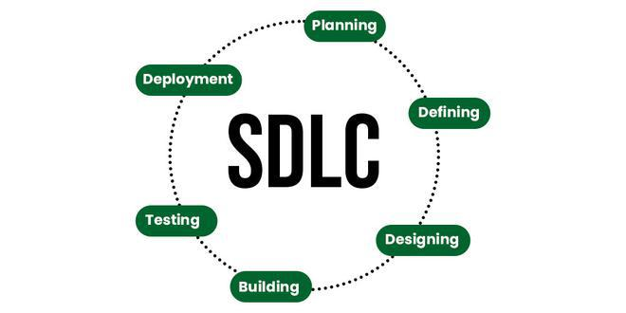SDLC
Stages of the Software Development Life Cycle
SDLC specifies the tasks to be performed at various stages by a software engineer or developer. It ensures that the end product is able to meet the customer's expectations and fits within the overall budget. Hence, it's vital for a software developer to have prior knowledge of this software development process. SDLC is a collection of these six stages, and the stages of SDLC are as follows:
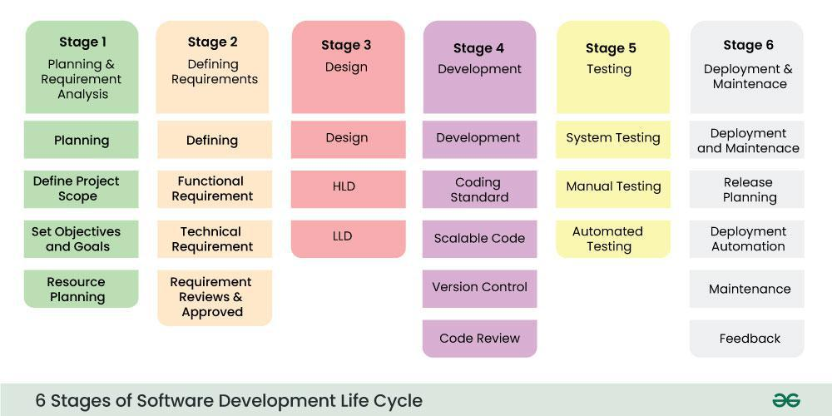Software Development Life Cycle Model SDLC Stages
The SDLC Model involves six phases or stages while developing any software.
Stage 1: Planning and Requirement Analysis
Planning is a crucial step in everything, just as in software development. In this same stage, requirement analysis is also performed by the developers of the organization. This is attained from customer inputs, and sales department/market surveys.
The information from this analysis forms the building blocks of a basic project. The quality of the project is a result of planning. Thus, in this stage, the basic project is designed with all the available information.
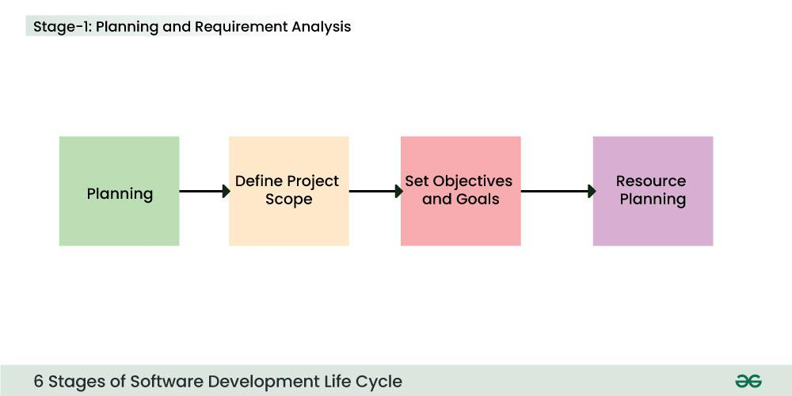Stage-1 : Planning and Requirement Analysis
Stage 2: Defining Requirements
In this stage, all the requirements for the target software are specified. These requirements get approval from customers, market analysts, and stakeholders.
This is fulfilled by utilizing SRS (Software Requirement Specification). This is a sort of document that specifies all those things that need to be defined and created during the entire project cycle.
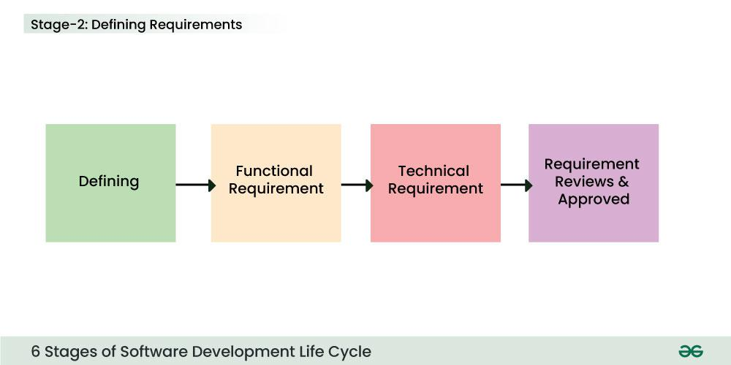Stage-2 : Defining Requirements
Stage 3: Designing Architecture
SRS is a reference for software designers to come up with the best architecture for the software. Hence, with the requirements defined in SRS, multiple designs for the product architecture are present in the Design Document Specification (DDS).
This DDS is assessed by market analysts and stakeholders. After evaluating all the possible factors, the most practical and logical design is chosen for development.
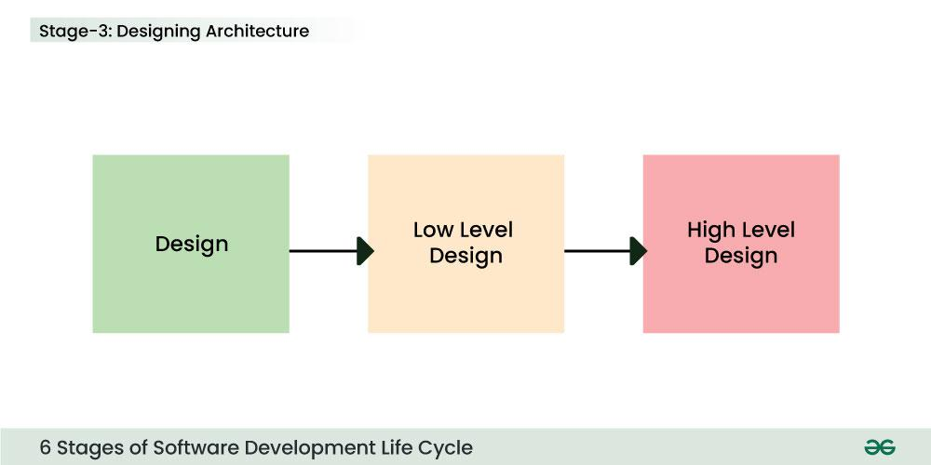Stage 3: Design
Stage 4: Developing Product
At this stage, the fundamental development of the product starts. For this, developers use a specific programming code as per the design in the DDS. Hence, it is important for the coders to follow the protocols set by the association. Conventional programming tools like compilers, interpreters, debuggers, etc. are also put into use at this stage. Some popular languages like C/C++, Python, Java, etc. are put into use as per the software regulations.
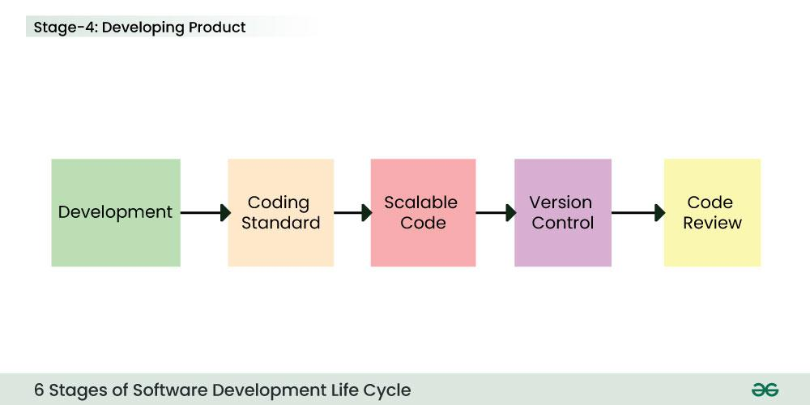Stage 4: Development
Stage 5: Product Testing and Integration
After the development of the product, testing of the software is necessary to ensure its smooth execution. Although, minimal testing is conducted at every stage of SDLC. Therefore, at this stage, all the probable flaws are tracked, fixed, and retested. This ensures that the product confronts the quality requirements of SRS.
Documentation, Training, and Support: Software documentation is an essential part of the software development life cycle. A well-written document acts as a tool and means to information repository necessary to know about software processes, functions, and maintenance. Documentation also provides information about how to use the product. Training in an attempt to improve the current or future employee performance by increasing an employee's ability to work through learning, usually by changing his attitude and developing his skills and understanding.
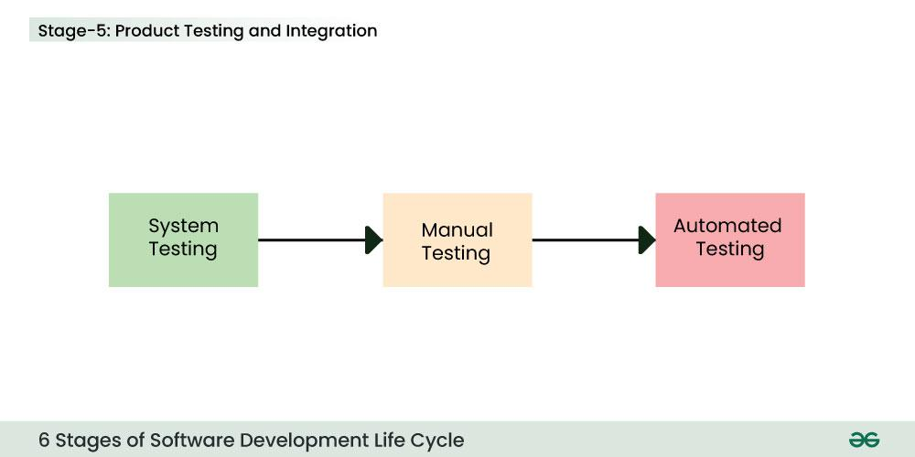Stage 5: Testing
Stage 6: Deployment and Maintenance of Products
After detailed testing, the conclusive product is released in phases as per the organization’s strategy. Then it is tested in a real industrial environment. It is important to ensure its smooth performance. If it performs well, the organization sends out the product as a whole. After retrieving beneficial feedback, the company releases it as it is or with auxiliary improvements to make it further helpful for the customers. However, this alone is not enough. Therefore, along with the deployment, the product's supervision.
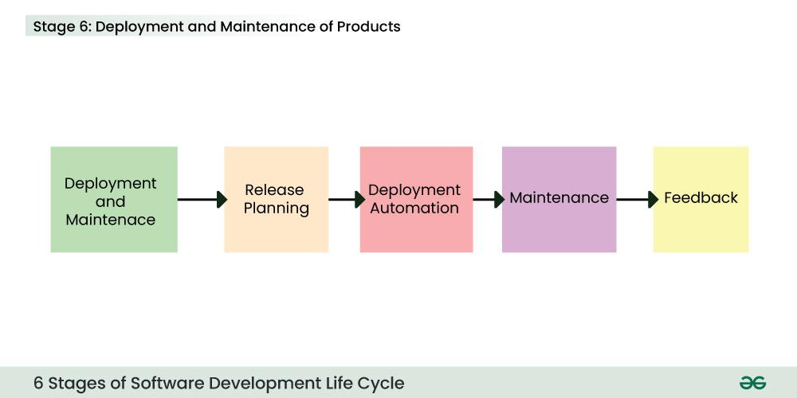Stage 6: Deployment and Maintenance
Software Development Life Cycle Models
Software Development Models are structured frameworks that guide the planning, execution, and delivery of software projects. They define the sequence of development stages, such as requirements, design, coding, testing, and deployment.
What are the main stages of the software development process?
1. Requirement Analysis
- Gather and analyze user needs.
- Define the functional and non-functional requirements.
- Outcome: Requirement Specification Document (SRS).

2. System Design
- Create architecture and system models.
- Define database structure, UI design, and system interfaces.
- Outcome: Design Document (High-level & Low-level design).

3. Implementation (Coding)
- Developers write the actual source code based on the design.
- Choose suitable programming languages, frameworks, and tools.
- Outcome: Working software modules.

4. Testing
- Test the software for bugs, errors, and performance issues.
- Conduct unit testing, integration testing, system testing, and user acceptance testing.
- Outcome: Verified and validated product.

5. Deployment
- Release the software to the production environment.
- May involve a pilot launch or phased rollout.
- Outcome: Operational software available to end-users.

6. Maintenance
- Provide updates, patches, and bug fixes.
- Improve performance and adapt to new requirements.
- Outcome: Continued usability and efficiency of the system.
LAB EXERCISE: Write a requirement specification for a simple library management system.

Software Requirement Specification (SRS)
for Library Management System (LMS)

1. Introduction
1.1 Purpose
The purpose of the Library Management System is to automate library operations such as book cataloging, member registration, book borrowing, returning, and report generation. The system will improve efficiency, reduce manual errors, and provide easy access to library resources.
1.2 Scope
- Users: Librarians, Members (students, staff), and Administrators.
- Main functions:
  - Manage books (add, update, delete).
  - Manage members (register, update, remove).
  - Borrow/return books with due date tracking.
  - Search for books by title, author, or subject.
  - Generate reports (issued books, overdue books, etc.).
1.3 Definitions
- Book ID: Unique identifier for each book.
- Member ID: Unique identifier for each registered member.
- Overdue: Book not returned within the allowed time.

2. Overall Description
2.1 User Classes & Characteristics
- Administrator: Manages users, system settings.
- Librarian: Handles book management, borrowing/returning.
- Member: Can search books, borrow, and return.
2.2 Operating Environment
- Web-based system accessible via browsers.
- Backend database (e.g., MySQL).
- Runs on Windows/Linux servers.
2.3 Constraints
- Only registered members can borrow books.
- Maximum borrowing limit per member (e.g., 5 books).
- Books must be returned within a fixed period (e.g., 14 days).

3. Functional Requirements
- Book Management
  - Add, edit, delete, and search books.
  - Track availability status.
- Member Management
  - Register new members.
  - Update and delete member records.
- Borrow/Return System
  - Record book issuance with due date.
  - Record return and calculate fines (if overdue).
- Search Functionality
  - Search by book title, author, category, or ISBN.
- Reports
  - View issued books.
  - View overdue books and fines.
  - Daily/Monthly summary reports.

4. Non-Functional Requirements
- Usability: Simple and user-friendly interface.
- Performance: Should handle at least 1000 books and 500 members.
- Security: Role-based access (Admin/Librarian/Member).
- Reliability: Data backup and recovery must be supported.

5. System Models
- Use Case Examples:
  - Librarian adds a new book.
  - Member searches for a book.
  - Librarian issues a book to a member.
  - Member returns a book.
THEORY EXERCISE: Why is the requirement analysis phase critical in software development? Software Analysis
1. Defines the Scope Clearly
- Helps identify what the system should do and what it should not do.
- Prevents misunderstandings between developers, clients, and users.

🔑 2. Reduces Development Risks
- Early identification of conflicting, incomplete, or unrealistic requirements.
- Minimizes costly rework during later stages.

🔑 3. Improves Cost & Time Estimation
- Clear requirements allow better planning of resources, budget, and timelines.
- Reduces chances of project overruns.

🔑 4. Acts as a Communication Bridge
- Provides a common reference point between stakeholders, developers, and testers.
- Ensures everyone shares the same understanding of the system.

🔑 5. Ensures User Satisfaction
- Captures actual user needs instead of assumptions.
- Leads to a final product that meets expectations and solves the right problems.

🔑 6. Forms the Basis for Design & Testing
- Design models and architecture depend directly on requirements.
- Test cases are created to validate each requirement.
LAB EXERCISE: Perform a functional analysis for an online shopping system.
Functional Analysis: Online Shopping System
1. Actors (Users)
- Customer: Browses, purchases products, manages their account.
- Admin: Manages products, categories, users, and orders.
- Supplier (optional): Updates stock, provides product details.
- Payment Gateway: Handles transactions securely.
- Delivery/Logistics Partner: Manages shipping and tracking.

2. Functional Requirements
A. User Management
- Register new customers.
- Customer login/logout with authentication.
- Manage user profiles (name, address, contact, payment info).
- Password reset and account recovery.
B. Product Management
- Admin adds/updates/deletes products.
- Categorize products (e.g., electronics, clothing).
- Upload product images, descriptions, prices, and stock details.
C. Product Browsing & Search
- Customers browse products by category.
- Search by name, brand, or keywords.
- Apply filters (price, rating, availability).
- Sort products (by price, popularity, newest).
D. Shopping Cart & Wishlist
- Add/remove/update items in the cart.
- Save items in a wishlist for later purchase.
- Display subtotal, taxes, and final price dynamically.
E. Order Management
- Place orders with selected products.
- Provide delivery address and shipping options.
- Track order status (processing, shipped, delivered).
- Order cancellation and return options.
F. Payment Processing
- Integration with payment gateways (PayPal, credit/debit cards, etc.).
- Secure payment validation and confirmation.
- Generate invoices/receipts.
G. Delivery & Logistics
- Calculate shipping charges based on location.
- Provide estimated delivery dates.
- Track shipments in real-time.
H. Reviews & Ratings
- Customers can rate purchased products.
- Write reviews and provide feedback.
I. Reports & Analytics (Admin)
- Sales reports (daily/weekly/monthly).
- Customer purchase history.
- Inventory reports (low-stock alerts).

3. Non-Functional Considerations (Supportive)
- Security: Encrypt sensitive data (passwords, payment info).
- Performance: Support high traffic during peak times (e.g., sales events).
- Scalability: Handle growing number of products and customers.
- Usability: Intuitive interface for both customers and admins.

4. Use Case Examples
- Customer searches for a product and adds it to the cart.
- Customer places an order and pays online.
- Admin updates product stock after new shipment.

- System generates sales report for the admin.

THEORY EXERCISE: What is the role of software analysis in the development process?
Role of Software Analysis in Development
1. Understanding the Problem Domain
- Identifies the real-world problem the software is supposed to solve.
- Ensures the development team understands user needs, goals, and constraints.

2. Defining Requirements Clearly
- Gathers functional requirements (what the system should do) and non-functional requirements (performance, security, usability, etc.).
- Prevents ambiguity and misinterpretation between clients and developers.

3. Feasibility Study
- Evaluates technical, economic, and operational feasibility.
- Helps decide whether the project should proceed, be modified, or abandoned.

4. Providing a Blueprint for Design
- Analysis outputs (like SRS – Software Requirement Specification) act as the foundation for system design.
- Ensures design and coding are aligned with user expectations.

5. Reducing Risks & Costs
- Identifies potential conflicts, gaps, or unrealistic expectations early.
- Saves time and money by avoiding rework in later phases.

6. Facilitating Communication
- Acts as a bridge between stakeholders and developers.
- Ensures both technical and non-technical teams share a common understanding.

7. Supporting Testing & Validation
- Requirements defined during analysis are used to create test cases.
- Helps validate whether the final system meets user needs.

Lab exercise :Design a basic system architecture for a food delivery app.
Basic System Architecture – Food Delivery App
1. Actors (Users of the System)
- Customer – places orders, tracks deliveries.
- Restaurant – receives and prepares orders.
- Delivery Partner – accepts and delivers orders.
- Admin – manages restaurants, users, and system settings.

2. High-Level Architecture Layers
A. Frontend (User Interfaces)
- Customer App (iOS/Android/Web): Browse menu, place orders, track delivery.
- Restaurant App/Dashboard: Manage menu, accept/reject orders.
- Delivery Partner App: Get delivery requests, navigate routes, update order status.
- Admin Dashboard: Manage restaurants, users, and reports.

B. Backend (Application Layer)
- User Management Service
  - Authentication & Authorization (login, signup, roles).
  - Profile management.
- Restaurant & Menu Service
  - Manage restaurant listings and menus.
  - Update availability and pricing.
- Order Management Service
  - Place and update orders.
  - Handle order status (pending, preparing, out-for-delivery, delivered).
- Delivery Management Service
  - Assign delivery partner based on location.
  - Route optimization & live tracking.
- Payment Service
  - Integrate payment gateways (credit card, wallet, UPI, PayPal).
  - Manage refunds and transaction records.
- Notification Service
  - Push notifications (order updates, promotions).
  - SMS/Email alerts.
- Review & Rating Service
  - Customer feedback on restaurants and delivery.

C. Data Layer (Database & Storage)
- Relational DB (e.g., PostgreSQL/MySQL) for structured data: users, restaurants, orders.
- NoSQL DB (e.g., MongoDB/Redis) for caching menus, fast queries.
- Cloud Storage for media (menu images, receipts).

D. External Integrations
- Payment Gateway (Stripe, PayPal, Razorpay).
- Maps API (Google Maps, Mapbox) for route tracking.
- SMS/Email API (Twilio, SendGrid) for notifications.

3. System Workflow (Simplified)
- Customer browses restaurant → selects food → adds to cart → places order.
- Backend verifies payment & order details → sends order to restaurant.
- Restaurant accepts order → updates status to "preparing."
- Delivery system assigns a nearby driver → driver accepts → live tracking enabled.
- Order is picked up → marked as "out-for-delivery."
- Customer receives food → status updated to "delivered."
- Customer rates order & delivery → feedback stored.

THEORY EXERCISE: What are the key elements of system design?
1. Architecture Design
- High-level structure of the system.
- Defines how components (frontend, backend, database, external services) interact.
- Example: Monolithic vs. Microservices architecture.

🔑 2. Data Design
- Defines how data is stored, organized, and accessed.
- Includes database schemas, data models, entity-relationship diagrams (ERD).
- Ensures data integrity, consistency, and security.

🔑 3. Interface Design
- Specifies how users and other systems interact with the system.
- Includes UI/UX design (for end-users) and APIs (for system-to-system communication).

🔑 4. Component Design (Modularity)
- Breaks system into smaller, manageable modules/services.
- Defines each component’s responsibilities, inputs, and outputs.
- Promotes reusability and easier maintenance.

🔑 5. Security Design
- Defines mechanisms for authentication, authorization, encryption, and auditing.
- Ensures confidentiality, integrity, and availability of data.

🔑 6. Scalability & Performance Design
- Ensures the system can handle increasing loads (users, data, transactions).
- Includes caching, load balancing, replication, and distributed computing strategies.

🔑 7. Error Handling & Reliability
- Defines how the system deals with failures, crashes, or invalid inputs.
- Includes redundancy, backup, failover, and recovery mechanisms.

🔑 8. Integration Design
- Specifies how the system will connect with external services, APIs, and third-party platforms.
- Defines protocols, data exchange formats (JSON, XML), and middleware.

🔑 9. Deployment & Infrastructure Design
- Defines where and how the system runs (on-premises, cloud, hybrid).
- Includes server setup, CI/CD pipelines, containerization (Docker, Kubernetes).
THEORY EXERCISE: Why is software testing important?
1. Ensures Software Quality
- Detects bugs, errors, and defects before release.
- Guarantees that the software works as intended under different conditions.

🔑 2. Saves Time and Cost
- Fixing a bug in the requirement or design phase is much cheaper than fixing it after deployment.
- Prevents costly failures in production.

🔑 3. Improves Security
- Identifies vulnerabilities and loopholes that attackers could exploit.
- Especially important for systems handling finance, healthcare, and personal data.

🔑 4. Validates Requirements
- Ensures the software meets the functional and non-functional requirements defined in the SRS (Software Requirement Specification).
- Confirms that the product solves the intended problem.

🔑 5. Enhances User Satisfaction
- A well-tested product is more reliable and user-friendly.
- Leads to higher customer trust and satisfaction.

🔑 6. Supports Continuous Improvement
- Provides feedback to developers for improving performance, usability, and scalability.
- Helps maintain quality in Agile and DevOps environments where frequent releases occur.

🔑 7. Reduces Risk of Failure
- Early detection of critical issues prevents system crashes, data loss, or business disruptions.
- Ensures stability and reliability in real-world usage.
LAB EXERCISE: Document a real-world case where a software application required critical maintenance.
Real-World Case: Knight Capital Trading Glitch (2012)
📌 Background
Knight Capital Group, a major U.S. financial services firm, operated high-frequency trading systems. In August 2012, they deployed a new software update to their trading platform.

⚠️ The Issue
- A maintenance failure occurred:
  - During deployment, old code that should have been removed was reactivated.
  - Some servers were updated, but others still contained outdated, conflicting code.
  - As a result, every time Knight attempted to trade, the system issued multiple erroneous orders per second.

💥 Impact
- Within 45 minutes, Knight Capital lost $440 million.
- The company was pushed to the brink of bankruptcy.
- Eventually, it was acquired by another firm (Getco), effectively ending its independence.

🔧 Required Critical Maintenance
To stabilize the situation:
- Emergency code rollback was performed to remove the faulty update.
- Servers were synchronized to ensure consistent versions.
- Rigorous maintenance and deployment procedures (e.g., version control, automated testing, rollback strategies) were implemented after the incident.

📚 Lessons Learned
- Incomplete maintenance (leaving old, unused code) can have catastrophic consequences.
- Proper configuration management and testing are crucial before updates go live.
- Critical maintenance should include:
  - Code cleanup (removing obsolete modules).
  - Standardized deployment procedures.
  - Automated rollback in case of failures.
THEORY EXERCISE: What types of software maintenance are there?

1. Corrective Maintenance
- Purpose: Fixes errors and defects found after the software is released.
- Example: Patching a bug that causes the app to crash when users log in.

🔑 2. Adaptive Maintenance
- Purpose: Modifies software to work in a new or changed environment (hardware, operating system, business rules, regulations).
- Example: Updating an app to run on a new version of iOS/Android, or ensuring compliance with new tax laws.

🔑 3. Perfective Maintenance
- Purpose: Enhances functionality, performance, or user experience without fixing errors.
- Example: Adding a new feature to an e-commerce app (like product recommendations), or improving system speed.

🔑 4. Preventive Maintenance
- Purpose: Improves software reliability by anticipating and fixing potential issues before they occur.
- Example: Refactoring code to reduce complexity, updating libraries for security, or optimizing database queries.

THEORY EXERCISE What are the key differences between web and desktop applications?
Web Applications vs 🖥️ Desktop Applications
Feature | Web Application | Desktop Application
Definition | Runs in a web browser | Installed on a computer
Installation | No installation needed | Must be installed on system
Access | Accessed via internet/browser | Accessed directly from PC
Platform Dependency | Platform independent (works on any OS with browser) | Platform dependent (Windows/Mac/Linux specific)
Updates | Automatic (server-side updates) | Manual updates needed
Internet Requirement | Usually requires internet | Can work offline
Performance | Depends on browser & internet | Generally faster and more powerful
Storage | Data stored on server/cloud | Data stored locally on computer
Security | Depends on web security (HTTPS, auth) | Can be more secure locally
Examples | Gmail, Facebook, Online Banking | MS Word, VLC Player, Photoshop

